Article information

Cacioppo, J., Cacioppo, S., Gonzaga, G., Ogburn, E., VanderWeelle, T. (2013). Marital satisfaction and break-ups differ across on-line and off-line meeting venues. Proceedings of the National Academy of Sciences of the United States of America, 110(25): 10135-10140.

Abstract

Marital discord is costly to children, families, and communities. The advent of the Internet, social networking, and on-line dating has affected how people meet future spouses, but little is known about the prevalence or outcomes of these marriages or the demographics of those involved. We addressed these questions in a nationally representative sample of 19,131 respondents who married between 2005 and 2012. Results indicate that more than one-third of marriages in America now begin on-line. In addition, marriages that began online, when compared with those that began through traditional offline venues, were slightly less likely to result in a marital breakup (separation or divorce) and were associated with slightly higher marital satisfaction among those respondents who remained married. Demographic differences were identified between respondents who met their spouse through on-line vs. traditional off-line venues, but the findings for marital break-up and marital satisfaction remained significant after statistically controlling for these differences. These data suggest that the Internet may be altering the dynamics and outcomes of marriage itself.

Introduction

The rise in the Internet has transformed how Americans work, play, search, shop, study, and communicate. Facebook has grown from its inception in 2004 to over a billion users, and Twitter has grown from its start in 2006 to more than 500 million users. The 2011 American Time Use Survey indicates that, on average, men now spend 9.65% and women spend 6.81% of their leisure time on-line (1). The Internet has also changed how Americans meet their spouse. Meeting a marital partner in traditional off-line venues has declined over the past several decades but meeting on-line has grown dramatically (2), with on-line dating now a billion-dollar industry (3).

Experiments in which strangers are randomly assigned to interact using computer-mediated communications versus face-to-face communications show that the more anonymous on-line meetings produce greater self-disclosure and liking as long as the interaction is not under strong time constraints (3–6). Consistent with these experimental studies, research of on-line users suggests that authentic on-line self-disclosures are associated with more enduring face-to-face friendships (5). Rosenfeld and Thomas (2) provide some evidence that relationship quality for partners who meet on-line may be higher and the 1-y break-up rate slightly lower than for partners who meet off-line. Solid empirical evidence on the marital outcomes associated with meeting on-line vs. off-line is absent, however (3).

Here we report the results of a nationally representative survey of 19,131 respondents who married between 2005 and 2012 (Methods) to determine: (i) the likelihood that a marital relationship that began on-line vs. off-line ended in a marital break-up (i.e., divorce or separation); and (ii) the mean marital satisfaction of currently married respondents who met their spouse on-line vs. offline; and (iii) the extent to which the specific on-line venue, or the specific off-line venue, in which couples met is associated with marital satisfaction and marital break-ups. The latter analysis is important because on-line venues have tended to be treated as a homogenous terrain (2) despite on-line venues having grown in number, variety, and complexity.

Methods

Sampling

The authors’ involvement in and analysis of the data were reviewed and approved by the University of Chicago Institutional Review Board. The survey was conducted by Harris Interactive in June 2012. E-mail invitations to participate in an on-line survey were sent to 471,710 uSamp panelists. Of those who were e-mailed an invitation, 191,329 (40.06%) clicked on a Harris URL to electronically consent to take the survey.

To determine eligibility, respondents were asked to specify: (i) whether they had married since 2005 (including 2005) (Yes/No), (ii) their year of birth, and (iii) their country of residence. Eligibility criteria were that respondents resided in the United States, were at least 18 y of age, and reported being married at least once since the start of 2005. Of these 191,329 respondents, 122,265 were not eligible for the study based on these three criteria, 41,736 exited the survey early, and 7,207 were identified as fraudulent by uSample.

Fraudulent responding was defined by Harris Interactive and its contractors as: (i) multiple surveys from the same respondent; (ii) surveys that are completed too quickly to reflect valid data from a human respondent; (iii) surveys from computers with IP addresses that were not within the United States; (iv) surveys sent from a geographical address that was not within the United States; (v) surveys originating from a known list of “professional survey takers”; (vi) a survey from a respondent who is registered multiple times within the uSamp panel; (vii) surveys completed by respondents using an open proxy, which allows users to conceal or disguise their IP address; and (viii) respondents who gave incorrect responses to a respondent instruction. If a respondent met any of these criteria, Harris Interactive categorized the respondent as “Not Qualified.” Of the remaining 20,121 initially classified as qualified, 74 were identified by Harris Interactive as invalid based on evidence of response biases, such as straight-line responding and inaccurate responding to catchtrials or inconsistent responding, leaving a final sample of 20,047 (15.28%) respondents.

Harris Interactive uses a weighting procedure based on propensity scores to be representative of the population of individuals married between 2005 and 2012. The demographics of the sample are summarized in Table S1. The analyses reported in the text are on weighted means and sample sizes. Harris Interactive sampled individuals, not couples, and slightly more men than women who served as respondents in this study reported meeting their spouses on-line. This finding suggests that the sample is an approximation rather than a perfect representation of the true population.

Measures
Respondents were asked to specify their sex, their current marital status [Married, Divorced, Separated, Engaged, Single (never married), or Widowed], and (if not Single) the number of times they had been married since 2005 (including 2005) [Appendix S1 and Dataset S1 (the full dataset is available in SPSS ready format and is available upon request from any of the authors)]. For each marriage, participants were asked the month and year of the marriage and, if the most recent marriage ended in divorce, the month and year of the divorce.

Then for each marriage, beginning with the most recent, respondents were asked whether or not they had met that spouse on-line (Yes, No). If they specified on-line, respondents were asked where on-line did they meet (Chat room, On-line community, Instant messaging, Multiplayer on- line game, Virtual world, On-line dating site, Social networking site, E-mail, Discussion group or posting board, Message or comment on personal Web site, and Other). If participants reported meeting their spouse using an on- line dating site, they were additionally asked which site and were given a list that specified the 18 on-line dating sites with the greatest market share (i.e., Adult Friend Finder, American Singles, Chemistry, Christian café, Christian Dating, Christian Mingle, Christian Singles, eHarmony, JDate, Match, MSN Dating & Personals, OK Cupid, Perfect Match, Plenty of Fish, Singlesnet, True, Yahoo!Personals, Zoosk) and Other. For each of these questions, potential responses were given in random order.

If they reported meeting that spouse off-line, respondents were asked where off-line did they meet (At work, Through friends, At school, Through family members, At a bar/club, At a place of worship, At a social gathering with friends, We grew up together/Have known since child- hood, Through an arranged meeting/blind date, and Other). Potential responses were given in random order.

If the respondent was still married, she or he was asked a series of questions about the quality of the marriage. First, they were asked the four-item Couples Satisfaction index (CSI) (10), which included items such as “Please indicate the degree of happiness, all things considered, of your marriage,” and “In general, how satisfied are you with your marriage” on a scale of 1 “Extremely Unhappy” to 7 “Perfect.” The CSI was developed using Item Response Theory and provides excellent levels of precision and reliability (10). Consistent with prior research, the Cronbach α was excel- lent (α = 0.89) in our survey.

Next, respondents used a scale of 1 “Strongly Disagree” to 7 “Strongly Agree” to answer the following series of questions: “Thinking of your spouse, to what extent to you agree or disagree with the following statements? (a) “We have Chemistry”, (b) “We are happy”, (c) “We are able to understand each other’s feelings”, (d) “We are able to show each other affection”, (e) “We laugh a lot in our relationship”, (f) “We are able to disagree with one another without losing our tempers”, (g) “We ‘get’ each other”, (h) “We are in love”, (i) “We have great communication”, (j) “We are compatible”, and (k) “We trust each other.” Responses to these items were summed to create a second measure of relationship satisfaction. The Cronbach α for this scale was 0.97. The correlation between these two measures of marital satisfaction was 0.78, and a factor analysis confirmed that one factor was sufficient, so analyses were performed on the mean of these two measures.
Next, participants were asked a series of additional demographic questions, including their religion, their ethnic classification, their annual household income, their work status, and the number of children.

Descriptive statistics

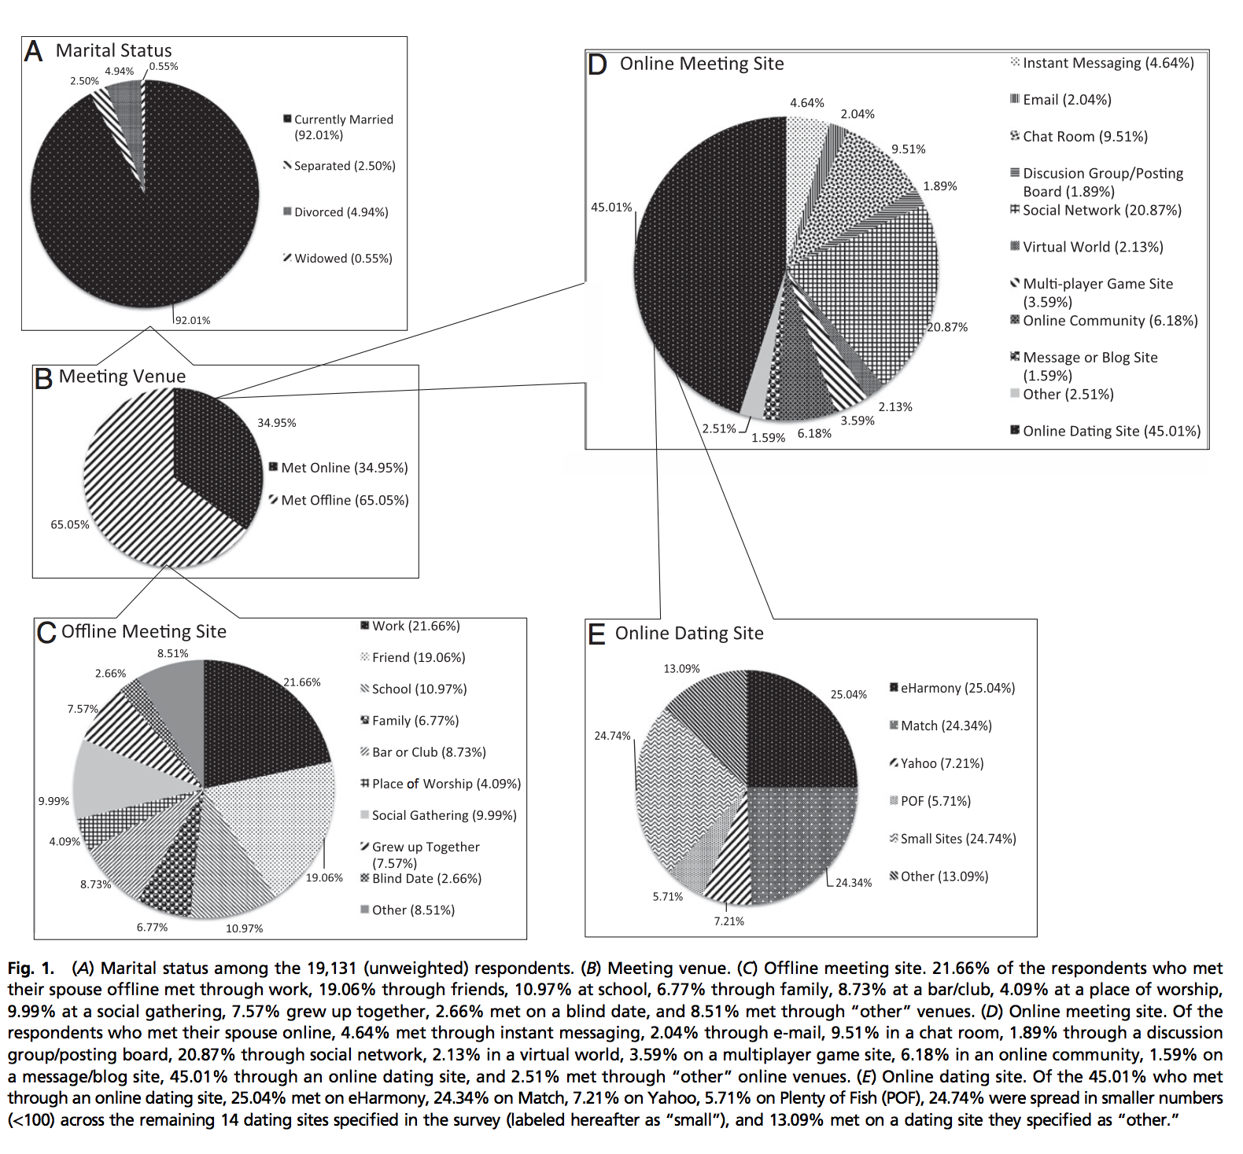

Results

Conclusion

In conclusion, marital outcomes are influenced by a variety of factors. Where one meets their spouse is only one contributory factor, and the effects of where one meets their spouse are understandably quite small and do not hold for everyone. The results of this study are nevertheless encouraging, given the paradigm shift in terms of how Americans are meeting their spouse. The present results addressed marital outcomes in the first 6 or 7 y of marriage, and longer-term follow-up studies are important to determine whether the observed differences in marital outcomes intensify or dissipate over even longer periods of time. Although our analyses concern American marriages, the rapid increase in the use of the Internet is a global phenomenon. The mechanisms suggested above as contributing to our findings may not be specific to America, so investigations are needed to determine whether marriages that begin on-line, in contrast to off-line, predict better marital outcomes in other countries and traditional societies. What is clear from this research is that a surprising number of Americans now meet their spouse on-line, meeting a spouse on-line is on average associated with slightly higher marital satisfaction and lower rates of marital break-up than meeting a spouse through traditional (off-line) venues, and on-line venues are not as homogeneous as thought in terms of marital outcomes. Indeed, the present study shows that the tendency in past studies to treat all on-line venues as the same is no longer empirically justified.

